23 February 2007 The Weekly Bulletin of Rotary Club of Kathmandu Mid-Town Bc # 34 of 2006-07
Rotary Club of Kathmandu Mid-Town
Breakfast Chatter




District : 3290 Web: www.rotarymidtown.org.np Club Id : 26776

FEBRUARY IS WORLD UNDERSTANDING MONTH
The internationality of its membership puts Rotary in a unique situation to promote peace and goodwill. Through club-to-club contacts, international service projects, peace programs, and cultural and educational exchanges, Rotary clubs worldwide make a meaningful contribution to world peace. But Rotary clubs make an equally meaningful contribution to peace through service in their own communities. Given the communal nature of many of today's conflicts, the homefront is an excellent arena for local Rotary clubs to begin advancing international understanding and goodwill.

Guest Speaker Dr Thomas McCaughey talked about his experience in teaching Nepali doctors
at the Club meeting on 16 February 2007.
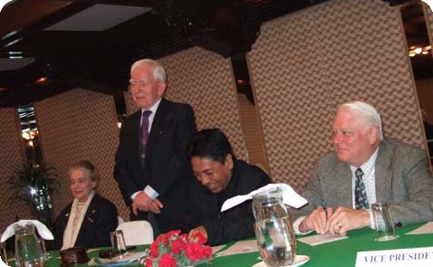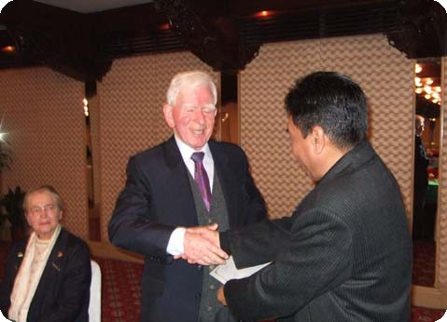
a) Guest Speaker Dr McCaughey talking to club members during his presentation;
b) Dr McCaughey shaking hand after receiving a Letter of Appreciation from
Actg President Surbarna Joshi. Ms McCaughey looks on.

Weekly Meetings and Programs :
Date | Program/Speaker | Program/Topics of Presentation
23 Feb 2007 | Club assembly | Club assembly
2 March 2007 | Jan S Roukema | Sharing African experience
9 March 2007 | Dr Susanne von der Heide | ?

Friday, 23 February :
The fourth club assembly is going to review whether the programs, activities and projects are in line with the plan, what have been the hurdles and how they are being addressed by the club. Progress review of ongoing projects will also be discussed during the club assembly.

Nepali languages :
With the introduction of Nepali language in the curriculum of North Carolina State University (NCSU), those enrolled in the course consider the development as a process of a dignified integration of Nepali community in the US system. NCSU, however, is not the only university that offers Nepali course. The language is taught in half a dozen American universities including the University of Oregon, University of California, University of Pennsylvania, University of Wisconsin, Columbia University and Harvard University.
Source: The Himalayan Times

Information Corner:
Reproductive Health :

One in every 10 Nepali women suffer from uterine prolapse, also known as 'fallen womb', states a study conducted by the Institute of Medicine. Women as young as 20 years old suffer from this condition, nearly 14 percent are aged between 20 and 29 years. The study, Reproductive Health Morbidity Needs Assessment in Nepal, was conducted with the objective of determining the magnitude of the reproductive health morbidity in Nepal. It was funded by the UN Population Fund (UNFPA) and the World Health Organization. The study was conducted among 2,849 married women of reproductive age (15 to 49 years) from eight districts of five regions. Of the 2,849 women, 2,070 were clinically examined in district hospitals.
Reproductive health indicators:
- the mean age at marriage is 15.36 years,
- nearly three-fourth of married women had their first pregnancy before they were 19,
- and a majority (91%) of these women have given birth at home.
Source: The Himalayan Times

On Lighter Side : Click at the figure ⇩


We may think we are only helping to equip a school, supply a clinic, or build a well for a faraway community. But in truth, what we are doing is helping to build a better, more stable, and more peaceful future.
RI President William B. Boyd

23 February 2007 The Weekly Bulletin of Rotary Club of Kathmandu Mid-Town Bc # 34 of 2006-07

Editor: RR Shrestha, Club Service Director email: rryes@wlink.com.np

